This chart is a combination of a Box Plot and a Density Plot that is rotated and placed on each side, to show the distribution shape of the data. The thick black bar in the centre represents the interquartile range, the thin black line extended from it represents the 95% confidence intervals, and the white dot is the median

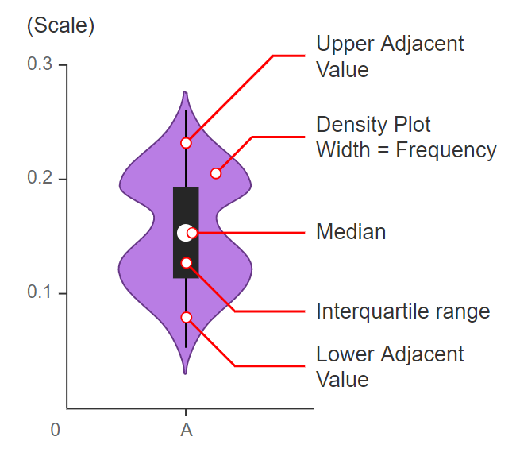

Below fig shows violin plot of IRIS dataset.

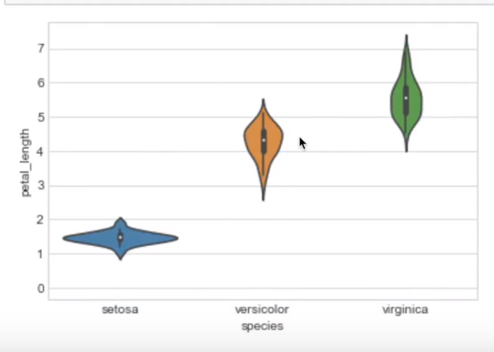

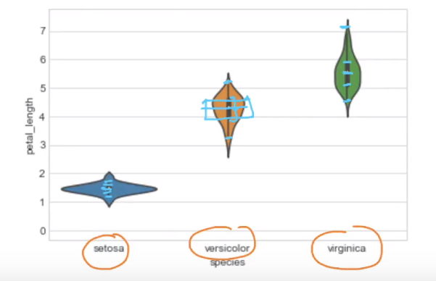

The bell shape figure around box plot is PDF.

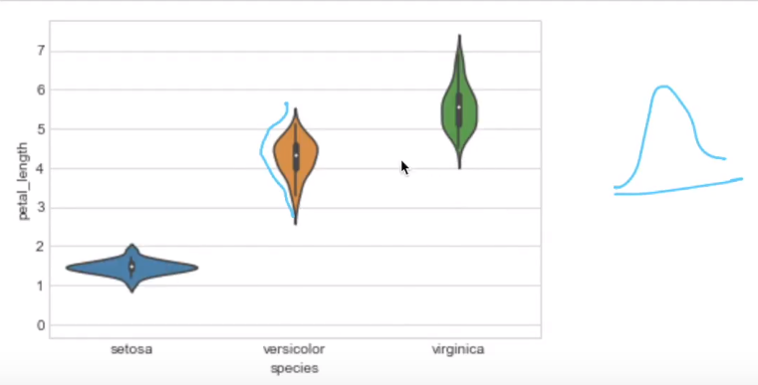

**Reasons for using violin graph.**

<https://blog.bioturing.com/2018/05/16/5-reasons-you-should-use-a-violin-graph/>